MEMORANDUM

TO: Mike Constantino, Chief – Program Review Section
Office of Policy, Planning

FROM: Debra Savage, Chairman
Illinois Health Facilities and Services Review Board

RE: Approval Application for Exemptions

Facility: #E-071-22-Ravine Way Surgery Center

This is to advise you that I have reviewed the above-captioned application for exemption and have determined the following:

X The request is in compliance with the requirements in Part 1130 is approved.

This request is to be reviewed by the Illinois Health Facilities and Services Review Board

This request is DENIED effective because it does NOT comply with the requirements specified in Part 1130.

Other actions as follows:

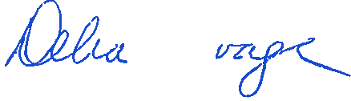 November 11, 2022

Debra Savage, Chairman Date
Illinois Health Facilities and Services
Review Board

