December 9, 2020 TRANSMITTED ELECTRONICALLY

Jacob M. Axel, President
Axel & Associates, Inc.
675 North Court Street, Suite 210
Palatine, IL 60506

RE: Completeness Requirements Met
Health Facilities Planning Act
PROJECT: 20-043 AMITA Health Mercy Medical Center Aurora, Aurora
APPLICANTS: Presence Central and Suburban Hospitals Network
Ascension Health

Dear Mr. Axel:

This is to acknowledge receipt of your application for permit under the Illinois Health Facilities Planning Act. Your application, received on December 9, 2020, was deemed complete as of December 9, 2020, and is considered a non-substantive project.

We have received your check in the amount of $2,500.00. The balance of your fee has been determined to be $48,653.59, and payment must be made to the Illinois Department of Public Health within thirty (30) days of your receipt of this notice.

Only EMERGENCY CON projects are charged no fee. Please make the check out for the exact amount, as rounding off dollar amounts complicates our records unnecessarily.

It is possible that a public hearing may be requested on your project pursuant to the provisions of Part 1130.910. If so, you will be contacted regarding the time and place for the public hearing.

A review of your project will be conducted by the State Agency and a report of findings will be submitted to the State Board. You will have an opportunity to review a copy of the report and appear before the State Board to answer any questions that members may have.
The State Agency Report and related materials for this project will be posted on the State Board website 14 days before the State Board meeting.

Consideration by the State Board has been tentatively scheduled for the March 16, 2021, State Board Meeting.

Should you have any questions regarding your application, please contact our office at (217) 782-3516 or TTY (800) 547-0466 for hearing impaired only.

Sincerely,
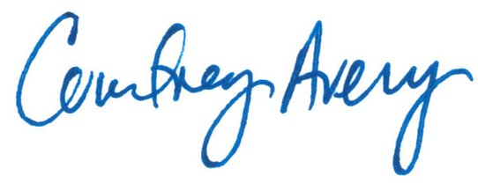
Courtney Avery
Administrator
Enclosure

NOTICE OF REVIEW AND OPPORTUNITY FOR PUBLIC HEARING AND WRITTEN COMMENT

In accordance with the requirements of the Illinois Health Facilities Planning Act, notice is given of receipt to perform a major modernization project at an existing acute care hospital, in Aurora. Project #20-043, AMITA Health Mercy Medical Center Aurora, Aurora. Applicants: Presence Central and Suburban Hospitals Network, and Ascension Health. The applicants propose to modernize and reduce the number of Emergency Department (ED) stations from 26 to 20 and develop Observation and Critical Stabilization Units (CSU), on the campus of AMITA Health Mercy Medical Center Aurora, 1325 North Highland Avenue, Aurora. Project cost: $23,251,630.

The application was declared complete on December 9, 2020. A copy of the application may be viewed at the Illinois Health Facilities and Services Review Board Office, at the address below. To obtain a copy of an application, please call the office for details and copying fees, at the number listed below. Consideration by the State Board has been tentatively scheduled for the March 16, 2021 State Board Meeting. Any person wanting a public hearing on the proposed project must submit a written request for a hearing to:

Mike Constantino, Supervisor, Project Review Section
Illinois Health Facilities and Services Review Board
525 West Jefferson Street (2nd Floor)
Springfield, Illinois 62761
(217) 782-3516
(TTY# 800-547-0466 for hearing impaired only)

Requests for hearings must be received by this Agency no later than December 24, 2020. Any person wanting to submit written comments on this project must submit these comments by February 24, 2021.

The State Board will post its findings in a State Board Staff Report, and the report will be made available via the internet on March 2, 2021. The public may submit written responses in support of or in opposition to the findings of the Illinois Health Facilities and Services Review Board. The public will have until 9:00 am, March 8, 2021. The internet address used to access this report is:

www.hfsrb.illinois.gov

